
Current Exhibit: The Emotional Guidance System: From Fear to Joy / Dialect
Running From: November 16 - 31, 2008
Opening: Friday, November 20th, 2008
473 Broadway, 7th Floor
New York, NY 10013
(212) 274-8993
Tues - Sat 10 - 6PM

The Portable Show curated by Stefania Carrozzini
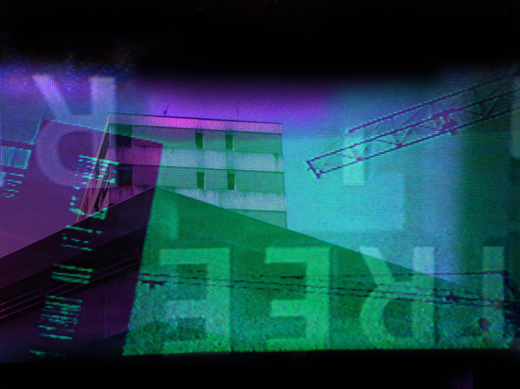

The Portable Show curated by Stefania Carrozzini at the BROADWAY GALLERY
December 1 to December 15, 2008

Reception: DECEMBER 4th at 6 pm
PATRONAGE: FONDAZIONE D’ARS OSCAR SIGNORINI ONLUS PRODUCTION AND ORGANIZATION: I AM. (INTERNATIONAL ART MEDIA) Milano – New York City – Beijing
Artists: NATALIA BERSELLI, ALESSANDRA COCCHI, ADRIANA COLLOVATI, MARCELLO DIOTALLEVI, ANNA GHISLENI, LIVE ART, SILVA NIRONE, ANNALISA PICCHIONI, PAOLA SCIALPI, KARL STENGEL
Broadway Gallery is pleased to announce the exhibition The Portable Show curated by Stefania Carrozzini and organized by I AM. (INTERNATIONAL ART MEDIA) from December 1 to December 15, with an opening reception on December 4, 6 p.m.
The exhibition features ten artists from Italy. For the show the curator contributes a text called Art Travels in Time and the Space of Creation. “Art travels and its vectors are physical and mental. It expands on the net; it dematerialises, yet at the same time it does not abandon substance and takes shape in all living forms; it maintains an outer layer, a shape that is perceivable in the real spatial and temporal dimension. Everything is in constant movement, things, ideas, people. They leave traces of energy in space. Time, in the game of creation, unites them in a unique design.”
Digital art has upset the traditional aura of the work of art and its physical immanence and the perceptive categories that we are used to. However, there is still a question to be asked. Why do artists continue to covet the tangible object, matter? Why do they insist on working on canvases, on marble, on paper, on the environment? Why not all take refuge in the virtual? Why not give themselves wholeheartedly to the cause of the immaterial? The temporal dimension that we are immersed in imposes its limits, freedom of movement, too. Should the idea inevitably take shape in matters such as searching for the most suitable body in which to reveal itself to the physical world, so as not to be shipwrecked in this ocean of images one has to manage and equip oneself as best as one can? A bit like in the film Cast Away in which Zemeckis, the main character played by Tom Hanks, a professional forwarding agent, an expert on national and global travel, tries to makes sense of his life and to resist the void that engulfs him. For the shipwrecked Zemeckis, the survival of symbols is more important than the material, more urgent than eating or sleeping, and for this reason he does not build a house; he does not give birth to a second universe that reminds him of his normal life. Nothing of all that. His fetish, his security blanket on the desert island, is a ball on which he has drawn a woman’s face in blood. It is this object that helps him hold on to a will to live. Perhaps destiny and the sense of art is just this: to nourish with symbols the body of the imaginary, establishing an ongoing effective relationship with reality. It is an attempt to heal, a need for redemption from the ontological loneliness within the subject itself, that which is anyway innate.
The technological deluge we are subjected to has not banished our desire to establish a concrete relationship with the object. Rather, it has filled it with even more expectations, symbolic references, whether one refers to an aesthetic or constructive dimension of the works of art. Beyond the means with which we express our need to give voice and substance to the imaginary, there remains the will of the human being to witness the power of thought and that which moves the law of the Universe and the process of creation. The exhibition is composed of 60 artworks, small-sized, mixed media, digital photographs, paintings, and drawings.

