



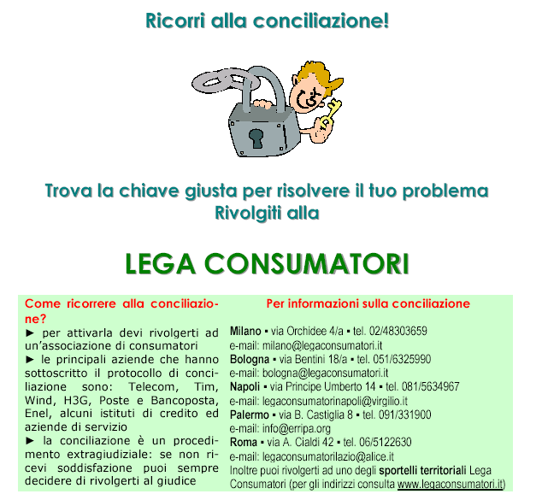
FORMIA – VIA Don luigi Sturzo, 53tel/fax 0771/790099
e-mail: lega consumatori.villano@tele2.it
www.legaconsumatori.lt.it

