Abbott Gee Sin
Hung Hay Goon
Lok Ah Choi
Wong Tai
Wong Kay Ying
Wong Fei Hung
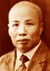
Lam Sai Wing
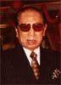
Lam Cho
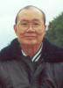
Tang Kowk Wah
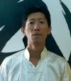
Tang Tung Wing

Maurizio Zanetti
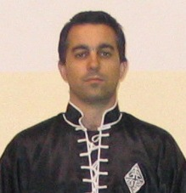
Davide Giovannini

